

Preparation of a Formatted Entry for the Dam Safety 2024 Conference Proceedings

# ****Author Name I, Suffixes as applicable, Position/Title, Company/Agency; and Author Name II, Suffixes as applicable, Position/Title, Company/Agency****

**Basic guidelines for the preparation of a technical paper for the Dam Safety Conference Proceedings are presented here. This document is itself an example of the desired layout and should be used as a template. It contains information regarding format, type sizes, and typefaces. Style rules are provided to describe how to handle equations, units, figures, tables, abbreviations, and acronyms. Sections are also devoted to the preparation of acknowledgments, references, and authors' biographies.**

**ABSTRACT**

**Please provide a short abstract as part of the paper. The abstract is limited to 150 words and cannot contain equations, figures, tables, or references. It should concisely state what was done, how it was done, principal results, and their significance.**

## Introduction

This document is an example of the desired layout for a Dam Safety Conference Proceedings entry. It contains information regarding format, type sizes, and typefaces. Style rules are provided to describe how to handle equations, units, figures, tables, abbreviations, and acronyms. Sections are also devoted to the preparation of acknowledgments, references, and authors’ biographies.

## Paper Preparation

Please triple-check your spelling and be consistent with hyphenation throughout the entire document. Make sure that all sentences are complete and that there is continuity within your paragraphs. Check the numbering of your graphics (figures and tables) and make sure that all appropriate references are included. Papers should be 8-12 pages in length.

## Template

This document should be used as a template for preparing your paper. You may type over sections of this document or cut and paste into it to produce a proceedings entry with the correct formatting.

## Format

If you choose not to use this document as a template, prepare your paper in single-spaced, single-column format, sized to fit 8.5×11-inch paper. Set the top, left and right margins to .75 inches and the bottom margin to 1 inch. Do not violate margins (i.e., text, tables, figures, and equations may not extend into the margins). Paragraph indentation is .25 inch. Use full justification. Use either one or two spaces between sections (6 to 12 pt), and between text and tables or figures, to adjust the column length. Apply the same footer and page number style that appears at the bottom of this page.

## Typefaces and Sizes

Use Arial fonts. Table I provides samples of the appropriate type sizes and styles to use. The paper title should be in uppercase and lowercase letters, **not** all uppercase. The Section headings are in all uppercase (All Caps).

## Section Headings

A primary section heading is enumerated by a Roman numeral followed by a period and is centered above the text. A primary heading should be in capital letters.

A secondary section heading (or subhead) is enumerated by a capital letter followed by a period and is flush left above the section. The first letter of each main word in this heading should be capitalized and the heading is bold and italicized.

TABLE I

Samples of Arial Type Sizes and Styles

|  |  |  |  |  |  |
| --- | --- | --- | --- | --- | --- |
| Body text, equations |  | Justified  1st Line Indent: .25 inch | 10 pt | Single Spaced | Spacing Between Paragraphs: 6 pt. |
| Footnotes, captions, table text, figure text |  | Left Justified | 9 | Single Spaced | Spacing Between Paragraphs: 6 pt. |
| Primary Section Heading | Bold, All Caps | Centered | 10 | Single Spaced | Spacing Between Paragraphs: 12 pt. |
| Secondary Section Heading | Bold, Italicized | Left Justified | 10 | Single Spaced | Spacing Between Paragraphs: 6 pt. |
| Author Names & Affiliations (Byline) | Bold | Centered | 12 | Single Spaced | Spacing Between Paragraphs: 12 pt. |
| Paper Title | Bold | Centered | 16 | Single Spaced | Spacing Between Paragraphs: 12 pt. |

## Figures and Tables

Figure axis labels are often a source of confusion. Try to use words rather than symbols. As an example, write the quantity "Magnetization," or "Magnetization, M," not just "M." Put units in parentheses. Do not label axes only with units. As in Figure 1, write "Magnetization (kA/m)" or "Magnetization (kA·m-1)," not just "kA/m." Do not label axes with a ratio of quantities and units. For example, write "Temperature (K)," not "Temperature/K." Figure labels should in 9-point type.

Place figure captions below the figures; place table captions above the tables. Do not put captions in "text boxes" linked to the figures.

All figures and tables must be placed in the text near, but not before, where they are first mentioned. Digitize your tables and figures. To insert images in Word, use Insert | Picture from File.

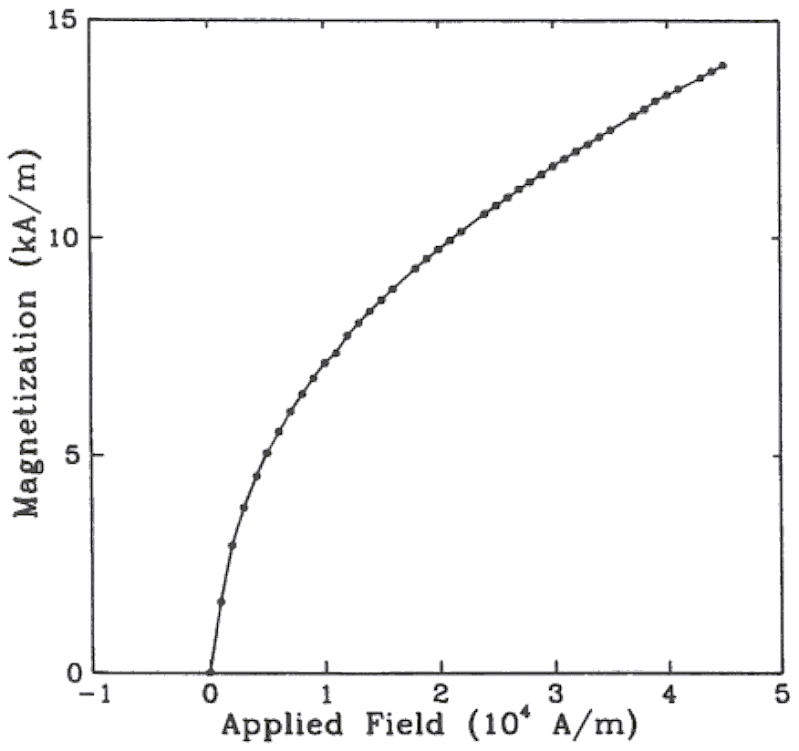

Figure 1. Magnetization as a function of applied field.

## Numbering

Number reference citations consecutively in square brackets [1]. Multiple references are each numbered with separate brackets [1]-[3]. Refer simply to the reference number, as in [3]. Do not use "Ref. [3]" or "reference [3]" except at the beginning of a sentence: "Reference [3] shows…."

Number footnotes separately with superscripts. Place each footnote at the bottom of the page in which it is cited. Do not put footnotes in the reference list. Letters can be used to identify table footnotes. Endnotes may be used in lieu of footnotes.

Check that all figures and tables are numbered correctly. Arabic numerals are typically used for figures and Roman numerals are used for tables.

Appendix figures and tables should be numbered consecutively with the figures and tables appearing in the rest of the paper. Do not start over or use a separate numbering system for figures and tables in the appendices.

## Units

Both English and Metric units are preferred for use in ASDSO publications, with Metric units listed as secondary (in parentheses). The use of the International System of Units (SI Units) is recommended.

## Abbreviations and Acronyms

Define less common abbreviations and acronyms the first time they are used in the text, even after they have been defined in the abstract. Do not use abbreviations in the paper title if possible.

## Math and Equations

Use either the Microsoft Equation Editor or the *MathType* commercial add-on for MS Word for all math objects in your paper (Insert | Equation *or* MathType Equation). Do not use "Float over text".

Number equations consecutively with equation numbers in parentheses as in (1). Be sure that the symbols in your equation have been defined before the equation appears or immediately following.

 where *IF* is the fault current.

## Appendix

Appendices, if needed, appear before the acknowledgment.

## Acknowledgment

If needed, an acknowledgment may be added before the References. Example:

The authors gratefully acknowledge the contributions of I. X. Austan, A. H. Burgmeyer, C. J. Essel, and S. H. Gold for their work on the original version of this document.

## References

References are important to the reader; therefore, each citation must be complete and correct. ASDSO does not conduct an editorial check on references; therefore, an incomplete or wrong reference will be published unless caught by a reviewer and will detract from the authority and value of the paper. References should be readily available publications.

List only one reference per reference number. If a reference is available from two sources, each should be listed as a separate reference. Give all authors' names; do not use *et al.*

Several tools are available for correctly formatting references in technical papers, including:

* Citation Machine (<http://www.citationmachine.net/>)
* The University of Maryland Global Campus (https://libguides.umgc.edu/apa-examples)
* The Institute of Electrical and Electronics Engineers (IEEE) (<http://www.ieee.org/documents/ieeecitationref.pdf>)

Please select a style that fits your needs and use it consistently in your References Section.

## Author Biographies

A short biography for the lead author or presenter must be included. Biographies of co-authors are encouraged, but not required. List the author’s name and contact information at top left and add a single paragraph bio-sketch (up to 200 words). No resumes or Curriculum Vitae will be accepted. See example:

Author Full Name

Position/Title

Company/Agency

Mailing Address

City, State, Zip

Phone/Email (optional)

[Author Name] is a registered professional engineer with over 30 years of experience in design, construction, and rehabilitation of dams and hydraulic structures. Mention work experience, research specialty and completed projects, courses taught, awards received, professional affiliations or memberships, and educational background.